Screenshots

1. Add Asset
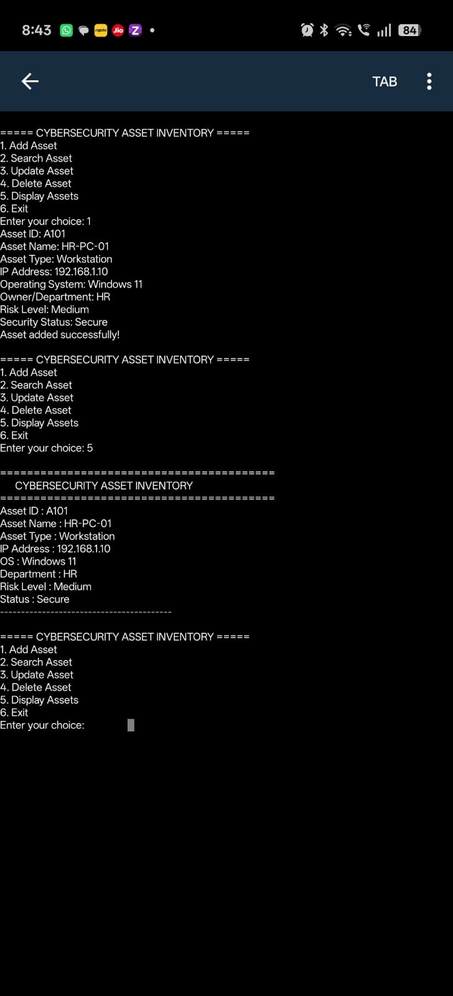

2. Search Asset
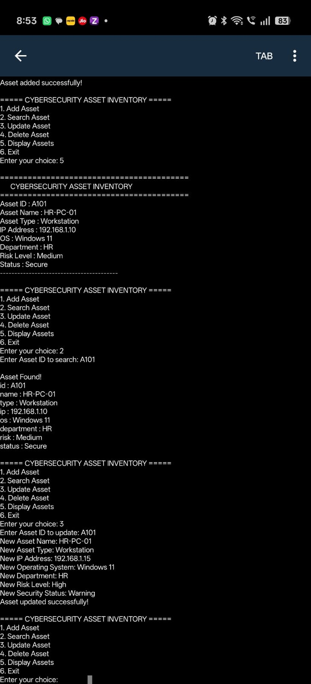

3. Update Asset
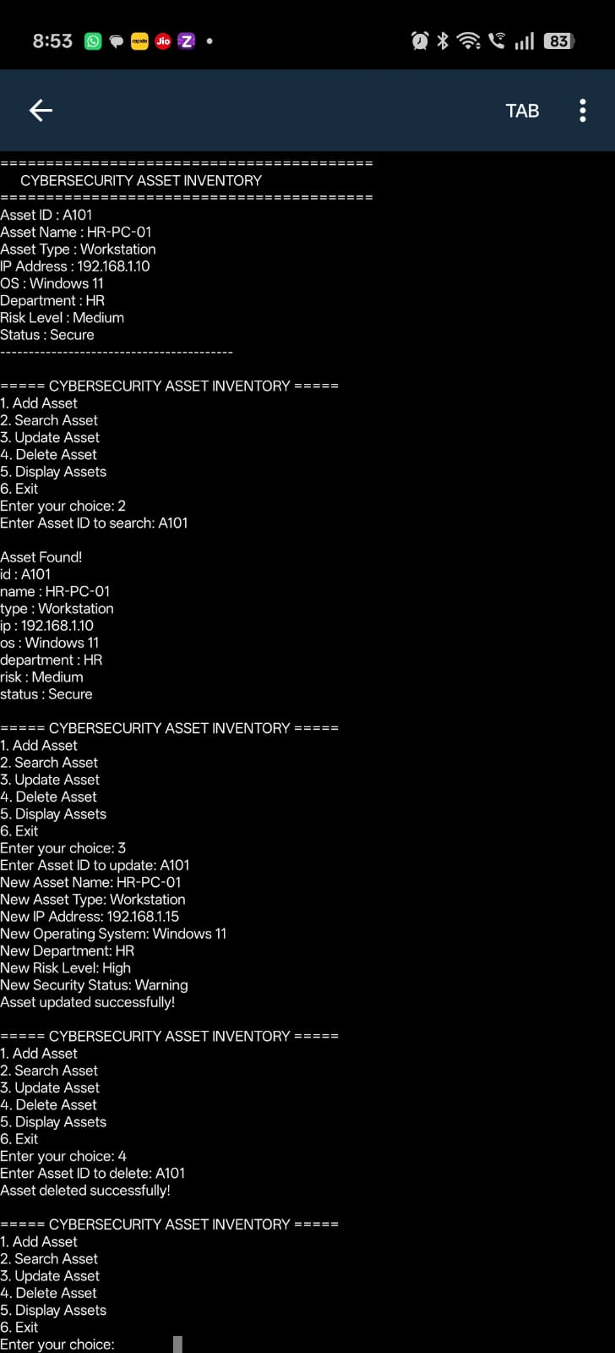

4. Delete Asset
Shown in the same run as the update above (choice 4 → Asset deleted successfully).

5. Add More Assets & Display All Assets
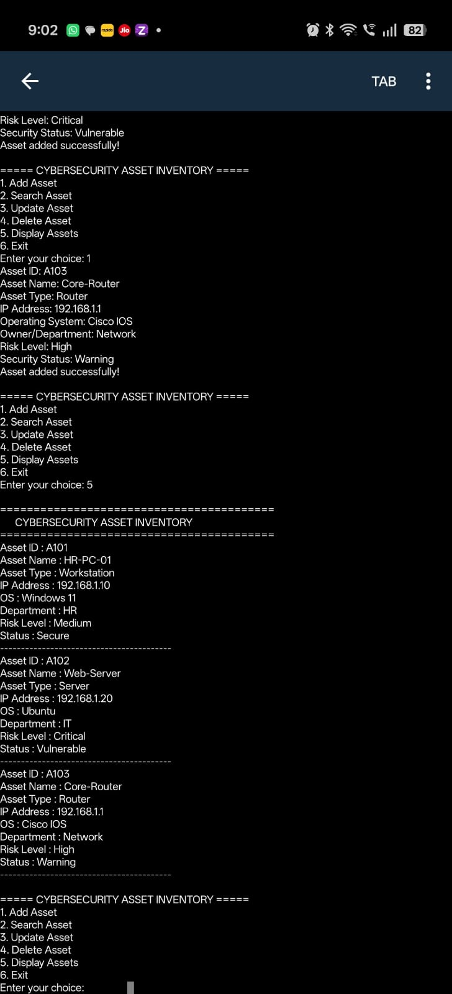

6. Final Display & Exit
